Home Automation Using Packet Tracer

A Project Report

Submitted by

Samarth Gupta (159101121)

In partial fulfilment for the award of the degree

Of

BACHELOR OF TECHNOLOGY

IN

COMPUTER SCIENCE & ENGINEERING

at



MANIPAL UNIVERSITY JAIPUR

JAIPUR

May 2018

Problem Statement

Many people are always on the move from place to place due to business demands. Some people can spend a couple of days away from their home leaving all their household appliances without any kind of monitoring and control. Some devices are left plugged into power sockets whereas others are supposed to be plugged into and out of power sockets at different intervals depending on the time of the day. All this requires an individual to manually attend to each of the devices independently from time to time. All such monitoring and control can be done without necessarily being around or inside the home. Some devices if not controlled properly consume a lot of energy which leads to extra expenditure on electricity. Therefore, we propose to design an internet-based home automation system which will enable one to remotely manage his/her appliances from anywhere, anytime.

Abstract

The Home Automation is a wireless home automation system that is supposed to be implemented in existing home environments, without any changes in the infrastructure. Home Automation let the user to control the home from his or her computer and assignations that should happen depending on time or other sensor readings such as light, temperature or sound from any device in the Home Automation network

With advancement of Automation technology, life is getting simpler and easier in all aspects. In today’s world Automatic systems are being preferred over manual system. With the rapid increase in the number of users of internet over the past decade has made Internet a part and parcel of life, and IoT is the latest and emerging internet technology. Internet of things is a growing network of everyday object-from industrial machine to consumer goods that can share information and complete tasks while you are busy with other activities. Wireless Home Automation system(WHAS) using IoT is a system that uses computers or mobile devices to control basic home functions and features automatically through internet from anywhere around the world, an automated home is sometimes called a smart home. It is meant to save the electric power and human energy. The home automation system differs from other system by allowing the user to operate the system from anywhere around the world through internet connection. In this project I present a Home Automation system(HAS) using Cisco Packet Tracer that employs the integration of cloud networking, wireless communication, to provide the user with remote control of various lights, fans, and appliances within their home and storing the data in the cloud. The system will automatically change on the basis of sensors’ data. This system is designed to be low cost and expandable allowing a variety of devices to be controlled.

Introduction

Homes of the 21st century will become more and more self-controlled and automated due to the comfort it provides, especially when employed in a private home. A home automation system is a means that allow users to control electric appliances of varying kind. Many existing, well-established home automation systems are based on wired communication. This does not pose a problem until the system is planned well in advance and installed during the physical construction of the building. But for already existing buildings the implementation cost goes very high.
In contrast, Wireless systems can be of great help for automation systems. With the advancement of wireless technologies such as Wi-Fi, cloud networks in the recent past, wireless systems are used every day and everywhere.

Advantages of Home automation systems:

In recent years, wireless systems like Wi-Fi have become more and more common in-home networking. Also, in home and building automation systems, the use of wireless technologies gives several advantages that could not be achieved using a wired network only.
1) Reduced installation costs: First and foremost, installation costs are significantly reduced since no cabling is necessary. Wired solutions require cabling, where material as well as the professional laying of cables (e.g. into walls) is expensive.
2) System scalability and easy extension: Deploying a wireless network is especially advantageous when, due to new or changed requirements, extension of the network is necessary. In contrast to wired installations, in which cabling extension is tedious. This makes wireless installations a seminal investment.
3) Aesthetical benefits: Apart from covering a larger area, this attribute helps to full aesthetical requirements as well. Examples include representative buildings with all-glass architecture and historical buildings where design or conservatory reasons do not allow laying of cables.
4) Integration of mobile devices: With wireless networks, associating mobile devices such as PDAs and Smartphones with the automation system becomes possible everywhere and at any time, as a device's exact physical location is no longer crucial for a connection (as long as the device is in reach of the network).
For all these reasons, wireless technology is not only an attractive choice in renovation and refurbishment, but also for new installations.
Home Automation is automation of home, housework or household activity. In other words, it refers to use of IT/computer to control home appliances. It integrates electrical devices in a house with each other. For example: It can include centralized control of lighting, appliances, security lock of gates & doors to provide improved convenience, comfort, energy, efficiency and safety. In today's IT world, home automation is being popular due to easiness, flexible means of viewing/monitoring and controlling the appliances and other things according to user’s comfort and needs. The challenging part lies in simplicity and cost of installing them in home and varies with increasing number of services to be monitored and controlled. This project named 'HOME AUTOMATION USING PACKET TRACER’ is idea of home automation using Cisco Packet Tracer. The popularity of home automation has been increasing greatly in recent years due to considerable affordability and simplicity through smartphone and tablet connectivity. A home automation system integrates electrical devices in a house with each other. The techniques employed in home automation include those in building automation as well as the control of domestic activities, such as lighting control system, and the use of other electrical appliances. Devices may be connected through a home network to allow control by a personal computer and may allow remote access from the internet. Through the integration of information technologies with the home environment, systems and appliances can communicate in an integrated manner which results in convenience, energy efficiency, and safety benefits. Due to the advancement of wireless technology, there are several different of connections are introduced such as GSM, WIFI, and Bluetooth. Each of the connection has their own unique specifications and applications. Among the four popular wireless connections that often implemented in Home Automation project, WIFI is being chosen with its suitable capability. The capabilities of WIFI are more than enough to be implemented in the design. Also, most of the current laptop/notebook or Smartphone come with built-in WIFI adapter. It will indirectly reduce the cost of this system.
This project deals about implementing smart home using new released cisco packet tracer because this feature includes different sensor, actuator and different smart device used for home automation. Some of the device are smart window, smart light, smart door, smart fan with different detector and sensor. To implement smart home, I used new released cisco packet tracer simulation software to design and configure IOE device with classically networking device.

Objective

The main objectives of our project are as follows:

- To remotely control home appliances and monitor them.
- To save time and utilize the energy efficiently
- To increase your independence and achieve greater control of home environment
- To make it easier to communicate with family
- To improve personal safety
- To alert visually to emergency situations

Methodology

In order to implement smart home, I used new released cisco packet tracer, which included different smart object used for home automation such as smart fan, smart window, smart door, smart light, smart siren, smart webcam and different sensor is included.

To control this smart object and sensor, Home Gateway is used, since it provides programming environment for controlling smart object connected to it and provide controlling mechanisms by registering smart device to Home Gateway respectively.

Home Gateway:

Home Gateway have 4 Ethernet ports in addition to a wireless access point configured with the "Home Gateway" SSID. To secure wireless connection WEP / WPA-PSK / WPA2 enterprise can be configured on home gateway.

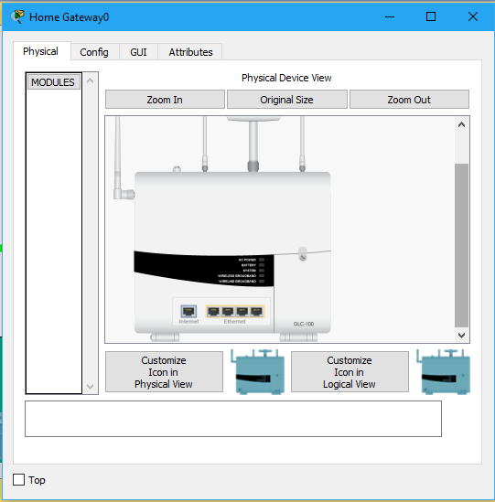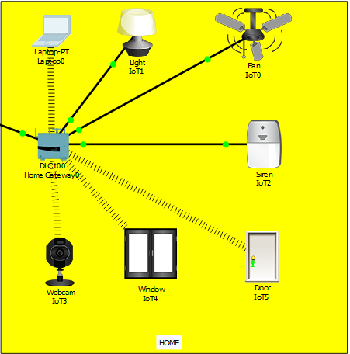

The figure shows six internet of Things device connected to a Home Gateway by using Ethernet cable and wireless. To connect the Home Gateway to the Internet its Internet WAN Ethernet port available on home getaway. The IoE device can be remotely managed through a web interface hosted by the Home Gateway. The Home Gateway internal (LAN) IP address is 192.168.25.1 but it can also be accessed through its Internet facing IP address.
The above figure shows the smart object is connected to the home Gateway using Ethernet cable and wireless medium to manage smart device local and remotely. Home gateway also works as DHCP server by assigning IP address to each smart device that connected to it, used to interconnect different smart object and provide programming environment with different language those are JavaScript, python and visual basic, to control the connected smart object.

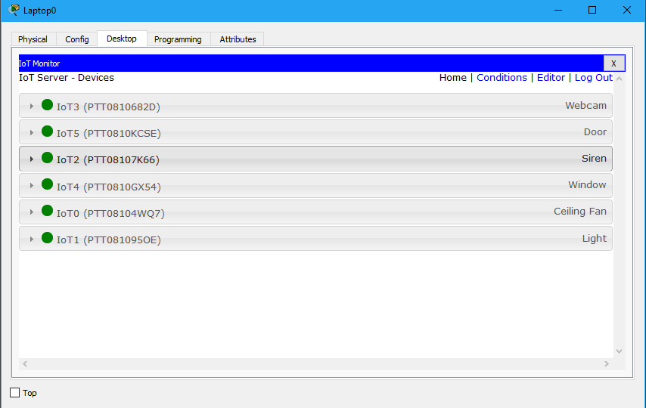

The above figure shows after registering smart device to home gateway all devices are accessed through web by legitimate user. There are six IOE device registered to Home gateway those all are controlled through web by legitimate person.

Implementation

To implement smart home using cisco packet tracer I used different sensor, smart device and detector to make smarter. The following figure represent the home architecture that connected each other using wireless and wired medium.

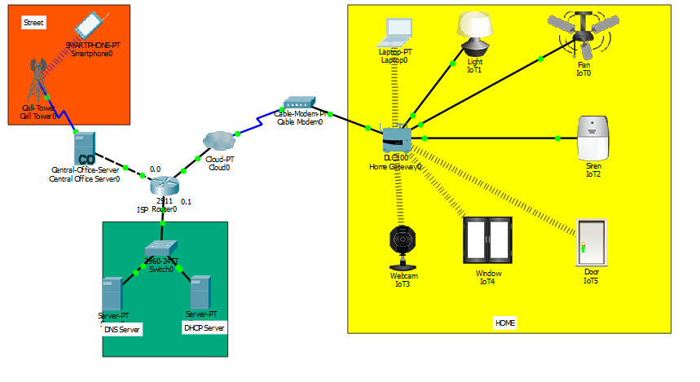

Device Configuration and Setup:
ISP Router Configuration
Assigning hostname and Ip address for ISP router
Router>
Router>enable
Router#conf terminal
Router(config)#hostname ISP
ISP(config)#intgigabitEthernet 0/2
ISP(config-if)#ip address 10.10.220.1 255.255.255.0
ISP(config-if)#no shutdown
ISP(config)#intgigabitEthernet 0/0
ISP(config-if)#ip address 209.165.200.225 255.255.255.224
ISP(config-if)#no shutdown
ISP(config)#intgigabitEthernet 0/1
ISP(config-if)#ip address 209.165.201.225 255.255.255.224
ISP(config-if)#no shutdown

Configurating dhcp server for cell and IOE device
ISP(config)#ipdhcp excluded-address 209.165.201.225 209.165.201.230
ISP(config)#ipdhcp pool cell
ISP(dhcp-config)#network 209.165.201.225 255.255.255.224
ISP(dhcp-config)#default-router 209.165.201.225
ISP(dhcp-config)#dns-server 10.10.220.10
ISP(config)#ipdhcp excluded-address 209.165.200.225 209.165.200.230
ISP(config)#ipdhcp pool ioe
ISP(dhcp-config)#network 209.165.200.224 255.255.255.224
ISP(dhcp-config)#default-router 209.165.200.225
ISP(dhcp-config)#dns-server 10.10.220.10

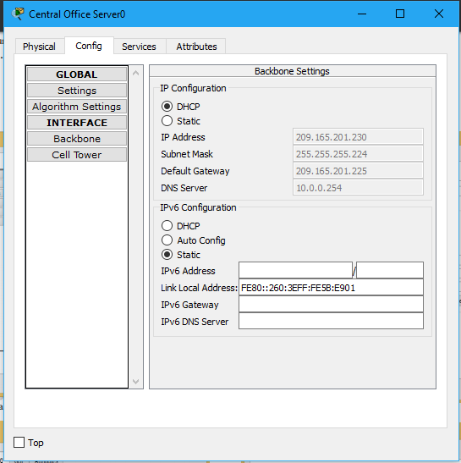

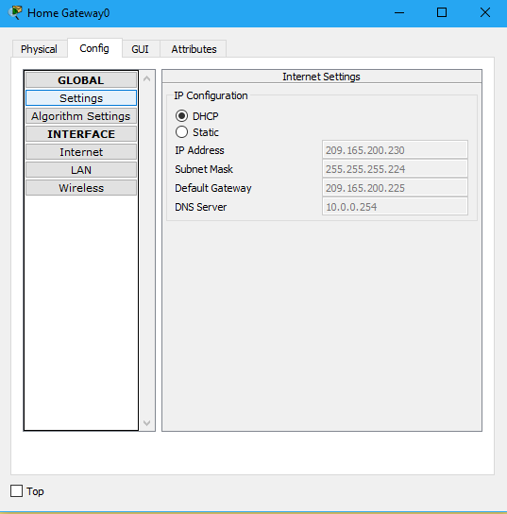

Software Used

Cisco Packet Tracer (https://www.netacad.com/courses/packet-tracer)

Sublime Text 3 (https://www.sublimetext.com/3)

Currently cisco released new version of packet tracer that include IOE device with classically networking device. Boards is also added to this version those are microcontrollers (MCU-PT), single boarded computers (SBC-PT) that provide programming environment to control connected object. Benefits of new released Packet Tracer are:
Offers a realistic simulation and visualization of IOT device
Permits users to design, build, configure smart home, smart city by providing different smart object used for them.
Provide board to control smart object
Allows students to explore concepts IOE
Provide detector for sensor

Results

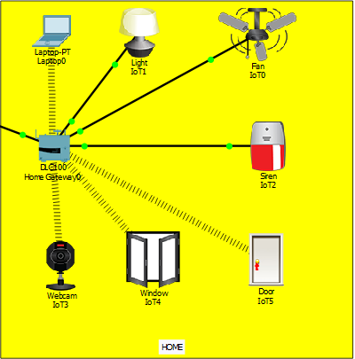

The figure above shows the light is on , the fan is moving at high speed , the door is unlocked , the siren is on , the window is open and webcam has started recording . This is based on the conditions made on the Home Gateway that the legitimate user is able to control the brightness of light (off , dim , on) , control fan speed (off , medium , high) , control door (lock , unlock) , control window (open , close) and monitor webcam recording.
After the successful connection to the server, the data of sensor are sent to the web server for monitoring of the system. the web server page which will allow us to monitor and control the system. By entering the assigned IP address in the web browser this web server page will appear. The web server gives the information about the temperature in different places of the house and motion state in the house. It also gives the status of the various electrical appliances like light, fan etc which we can control remotely.

Conclusion

In this project, I implemented smart home using new released cisco packet, because this version included different IOE device used for home automation. I used home Gateway to register smart device on it to control them and Microcontroller (MCU) to interconnect different sensor and IOE device. Also, MCU provide programming environment to manage different device, different programming language available on MCU but I used JavaScript and python to control the device.
As we all are aware that the world is getting more and more connected and IoT does just that. Many tech entrepreneurs are already starting off with IoT and making huge profits out of it. Keeping the profits aside, if we think of it in a broader way, then we conclude that IoT has a great future and in the next five years, it is going to revolutionize the world. IoT is like clay that can be moulded in any way we wish, if provided with enough skills and expertise.
The home automation using Internet of Things has been experimentally proven to work satisfactorily by connecting simple appliances to it and the appliances were successfully controlled remotely through internet. The designed system not only monitors the sensor data, like temperature, gas, light, motion sensors, but also actuates a process according to the requirement, for example switching on the light when it gets dark. It also stores the sensor parameters in the webpage (database) in a timely manner. This will help the user to analyse the condition of various parameters in the home anytime anywhere

References

[1] Chattoraj, Subhankar. "Smart Home Automation based on different sensors and Arduino as the master controller." International Journal of Scientific and Research Publications5.10 (2015): 1-4.

[2] Soliman, Moataz, et al. "Smart home: Integrating internet of things with web services and cloud computing." Cloud Computing Technology and Science (CloudCom), 2013 IEEE 5th International Conference on. Vol. 2. IEEE, 2013

[3] S. Haller S. Karnouskos and C. Schroth "The Internet of Things in an Enterprise Context " in Future Internet-FIS 2008 Lecture Notes in Computer Science Vol. 5468 2009 pp 14-28.

[4] Jie, Yin, et al. "Smart home system based on iot technologies." Computational and Information Sciences (ICCIS), 2013 Fifth International Conference on. IEEE, 2013

[5] http://www.packettracernetwork.com/

[6] Qin, X. U. E. "Simulation Experimental Teaching of Computer Network Based on Packet Tracer [J]." Research and Exploration in Laboratory 2 (2010): 57-59.

[7] http://www.packettracernetwork.com/internet-ofthings/pt7-iot-devicesconfiguration.htm

[8] Sun, Liangxu, et al. "Comparison between physical devices and simulator software for Cisco network technology teaching." Computer Science & Education (ICCSE), 2013 8th International Conference on. IEEE, 2013.

